# Lab: JS Basic Syntax, Conditional Statements and Loops

Problems for exercise and homework for the ["JS Fundamentals" Course @ SoftUni.](https://softuni.bg/trainings/3449/programming-fundamentals-with-javascript-september-2021)   
Submit your solutions in the SoftUni judge system at: <https://judge.softuni.org/Contests/1189>

## Multiply Number by 2

Write a function that receives a number and prints as result that number multiplied by two

### Examples

|  |  |
| --- | --- |
| **Input** | **Output** |
| 2 | 4 |
| 5 | 10 |
| 20 | 40 |

### Hints

Create a function called solve (or some other name). As parameters it will receive a number num.  
 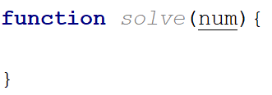

Print the result inside the function

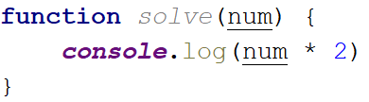

If you want to test your code locally, you need to call the function

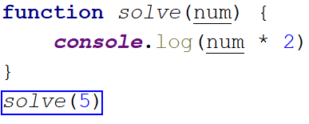

## Excellent Grade

Write a function that receives a single number and checks if the grade is excellent or not.   
If it is, print "**Excellent**", otherwise print "**Not excellent**"

### Examples

|  |  |
| --- | --- |
| **Input** | **Output** |
| 5.50 | Excellent |
| 4.35 | Not excellent |

### Hints

Check if the number given is greater or equal to 5.50 and print the corresponding result

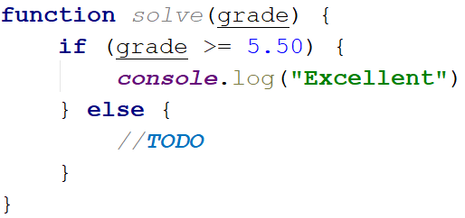

## Numbers from 1 to 5

Create a function that prints all the numbers from **1** **to** **5** (inclusive) each on a separate line

### Hints

Create a for loop starting from 1 and continuing until 5 and print the number

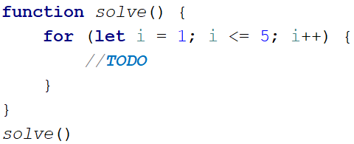

## Numbers from N to 1

Create a function that receives a number **N** and prints all the numbers from **N** **to 1**. Try using while loop

### Examples

|  |  |
| --- | --- |
| **Input** | **Output** |
| 5 | 5  4  3  2  1 |
| 3 | 3  2  1 |

### Hints

Create a while loop with condition **N >= 1**. Print **N** and decrease it with each step

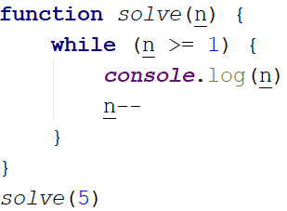

## Numbers from M to N

Write a function that receives a number **M** and a number **N** (M will always be bigger than N). Print all numbers from **M to N**

### Examples

|  |  |
| --- | --- |
| **Input** | **Output** |
| 6, 2 | 6 5  4  3  2 |
| 4, 1 | 4  3  2  1 |

### Hints

Use for or while loop and print the numbers.

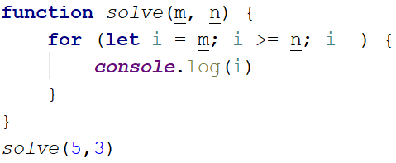

## Student Information

You will be given **3 parameters** – student name (string), age (number) and average grade (number). Your task is to print all the info about the student in the following format. The grade should be formatted to the **second decimal** point:

"Name: {student name}, Age: {student age}, Grade: {student grade}"

### Examples

|  |  |
| --- | --- |
| **Input** | **Output** |
| 'John', 15, 5.54678 | Name: John, Age: 15, Grade: 5.55 |
| 'Steve', 16, 2.1426 | Name: Steve, Age: 16, Grade: 2.14 |
| 'Marry', 12, 6.00 | Name: Marry, Age: 12, Grade: 6.00 |

### Hint

Use toFixed() method to format the grade.

1. First receive the input:

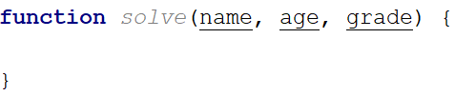

1. Print the output:



## Month Printer

Write a program, which takes an **integer** from the console and prints the corresponding **month**. If the number **is more than 12** or **less than 1** print "**Error!**"

### Input

You will receive a **single number**.

### Output

If the number is within the boundaries print the corresponding month, otherwise print "**Error!**"

### Examples

|  |  |  |  |  |
| --- | --- | --- | --- | --- |
| **Input** | **Output** |  | **Input** | **Output** |
| 2 | February |  | 13 | Error! |

## Foreign Languages

Write a program, which prints the language, that a given country speaks. You can receive only the following combinations: English **is spoken** in England and USA; Spanish **is spoken** in Spain, Argentina and Mexico; for the others**,** we should print "unknown".

### Input

You will receive a **single country name**.

### Output

**Print** the **language**, which the country **speaks**, or if it is **unknown** for your program, print **"**unknown**"**.

### Examples

|  |  |  |  |  |
| --- | --- | --- | --- | --- |
| **Input** | **Output** |  | **Input** | **Output** |
| USA | English |  | Germany | unknown |

### Hint

Think how you can **merge** multiple cases, in order to **avoid** writing more code than you need to.

## Theatre Promotions

A theatre **is doing a ticket sale**, but they need a program **to** calculate the price of a single ticket. If the given age does not fit one of the categories**,** you should print "Error!". You can see the prices i**n** the table below:

|  |  |  |  |
| --- | --- | --- | --- |
| **Day / Age** | **0 <= age <= 18** | **18 < age <= 64** | **64 < age <= 122** |
| **Weekday** | 12$ | 18$ | 12$ |
| **Weekend** | 15$ | 20$ | 15$ |
| **Holiday** | 5$ | 12$ | 10$ |

### Input

The input comes in **two parameters**. The **first** one will be the **type of day (string)**. The **second** – the **age** of the person (number).

### Output

Print the price of the ticket according to the table, or "**Error!**" if the age is not in the table.

### Constraints

* The age will be in the interval **[-1000…1000]**.
* The type of day will **always be** **valid**.

### Examples

|  |  |  |  |  |  |  |  |  |
| --- | --- | --- | --- | --- | --- | --- | --- | --- |
| **Input** | **Output** |  | **Input** | **Output** |  | **Input** | **Output** |  |
| 'Weekday',  42 | 18$ |  | 'Holiday', -12 | Error! | 'Holiday', 15 | 5$ |  |

## Divisible by 3

Write a program, which prints all the numbers from **1 to 100**, which are **divisible by 3**. You have to use a single for loop. The program should not receive input.

## Sum of Odd Numbers

Write a program that prints the next **n** **odd numbers** (starting from 1) and on the **last row** prints the **sum of them**.

### Input

You will receive a number – **n**. This number shows how many **odd numbers** you should print.

### Output

Print the next **n** odd numbers, starting from **1**, separated by **new lines**. On the last line, print the **sum** of these numbers.

### Constraints

* **n** will be in the interval **[1…100]**

### Examples

|  |  |  |  |  |
| --- | --- | --- | --- | --- |
| **Input** | **Output** |  | **Input** | **Output** |
| 5 | 1  3  5  7  9  Sum: 25 |  | 3 | 1  3  5  Sum: 9 |